Lab 4 Conditional Statements

## Instructions

1. Answer the below question in the boxes if needed.
2. Code on your computer and zip all your code before submission.
3. Please submit the assignment through TalentLabs Learning System.

## Part 0 Setting up your development environment (Optional for those who already have Node.js and Visual Studio Code set up)

### 0.1 Install the necessary softwares

In this section, you are going to set up your computer to install the necessary software for developing in JavaScript.

Task 0.1.1 Install Node.js

Please follow this step by step guide (included in the materials zip folder) in installing Node.js. This would enable you to run JavaScript programs on your computer.

Task 0.1.2 Install Visual Studio Code

Visual Studio Code is a code editor for software engineers. It is built by Microsoft and available for everyone for free. The idea of “code editor for software” is similar to “Microsoft Word to documents”.

Steps:

1. Go to the official website(<https://code.visualstudio.com/>) of Visual Studio Code to download the latest version of Visual Studio Code installer.

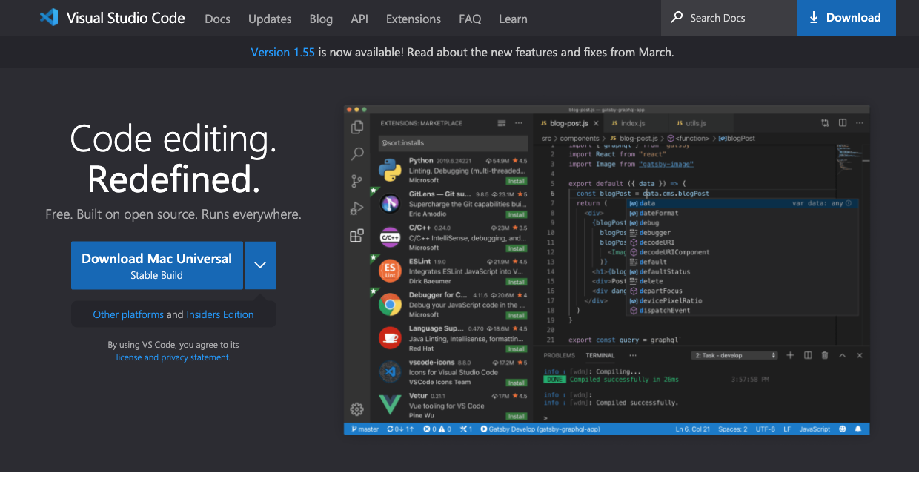

1. Once it is downloaded, run the installer (VSCodeUserSetup-{version}.exe). This will only take a minute. You can just leave all the options as-is.
2. By default, VS Code is installed under C:\users\{username}\AppData\Local\Programs\Microsoft VS Code.

Task 0.1.3 Test Your Development Environment

Steps:

1. Pick any place on your computer, and create a new folder and name it as “testjs”.
2. Open the Visual Studio Code software and pick “Open Folder”

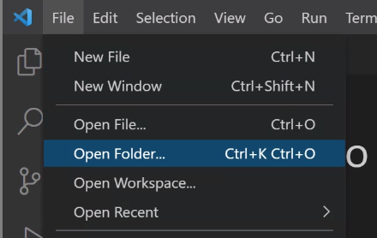

1. Then pick the folder you just created.

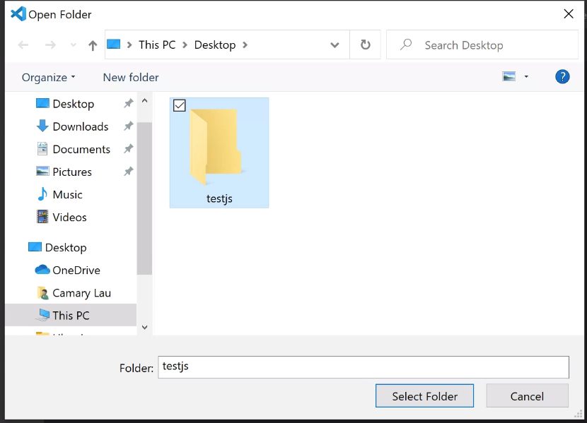

1. Create a new file in this folder by clicking the “New File” button.

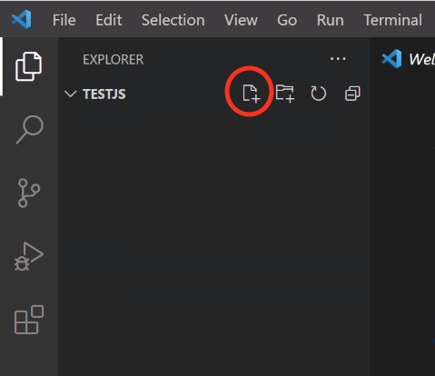

1. Give the new file name as “helloworld.js”. It should look like something like the screenshot below.

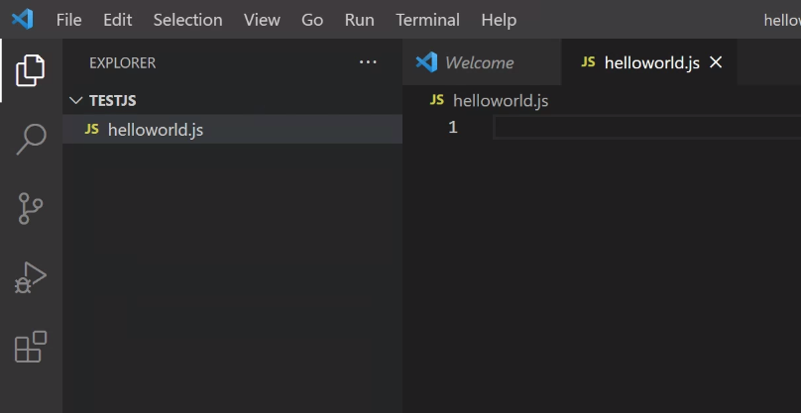

1. In the helloworld.js file, type in the following code.

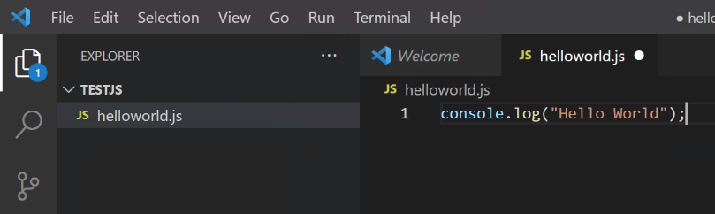

1. Then click “Run -> Run Without Debugging”

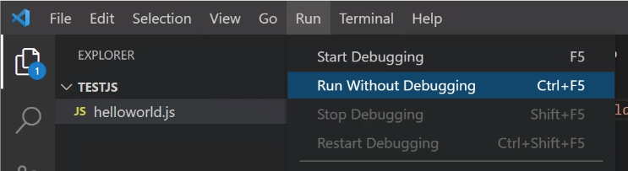

1. In the pop-up, pick Node.js
   1. If this doesn’t work, check the Setup Node.js Guide and restart your VSCode/Computer and try again.

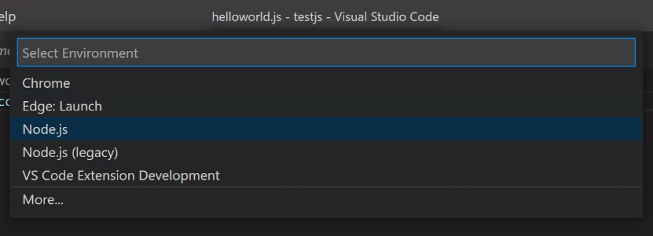

1. If it is successful, then you should see the output at the bottom of the window.

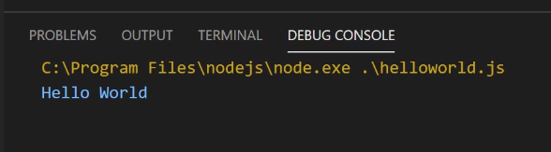

## Part 1 Logical Operators

### 1.1 Code Dry-running

In this section, you don’t need to write any code. Just try to run the code in your mind or on a piece of paper. DO NOT test the code with your computer.

**Please answer the questions based on this piece of code**

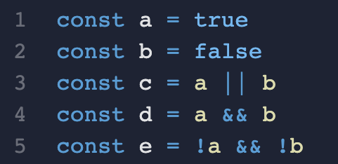

Question 1.1 What’s the output of the following statements? (Hint: the results might be more than 1 line)

Question 1.1.1

Statement: console.log(a && b)

|  |
| --- |
| false |

Question 1.1.2

Statement: console.log(b || c)

|  |
| --- |
| true |

Question 1.1.3

Statement: console.log(a || b || c)

|  |
| --- |
| true |

Question 1.1.4

Statement: console.log(a || b && c)

|  |
| --- |
| b && c: false -> true || false  Result: true |

Question 1.1.5

Statement: console.log(a || b && !c || !e)

|  |
| --- |
| Execute b && !c first (BODMAS method): true || false || false  Result: true |

Question 1.1.6

Statement: console.log(a && !b && !(c || d))

|  |
| --- |
| Parentheses first: true && !true  Result: false |

Question 1.1.7

Statement: console.log(e && b || !(a && c))

|  |
| --- |
| Parentheses first: false && !true  Result: false |

Question 1.1.8

Statement: console.log(a && !b && !(a || d))

|  |
| --- |
| Parentheses first: true && !true  Result: false |

### 

### 1.2 Code Dry-running 2 (Setting Backup Value for an Variable)

In this section, you don’t need to write any code. Just try to run the code in your mind or on a piece of paper. DO NOT test the code with your computer.

## **Please answer the questions based on this piece of code.**

Question 1.2 What’s the output of the following statements? (Hint: the results might be more than 1 line)

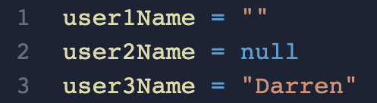

Question 1.2.1

Statement: console.log(user1Name || "No Name Provided")

|  |
| --- |
| “ ” empty string 0 -> is false  Result: false |

Question 1.2.2

Statement: console.log(user2Name || "No Name Provided")

|  |
| --- |
| Null is considered false  Result: No Name Provided |

Question 1.2.3

Statement: console.log(user3Name || "No Name Provided")

|  |
| --- |
| Darren |

## 

## Part 2 Conditional Statements (if, else if, else)

### 2.1 Code Exercises

Please download the lab4.zip from TalentLabs Learning Platform and unzip it. Then open the lab2 folder in Visual Studio and try to finish all the exercises.

There are 5 folders in lab4.zip. For folder 1 - 4, it follows the structure below. You just need to read the exercise instructions, and finish requirements in the “Add your code here” area.

If you did not touch the “Code Setup” part, the output of your code should look like the “Expected Output”.

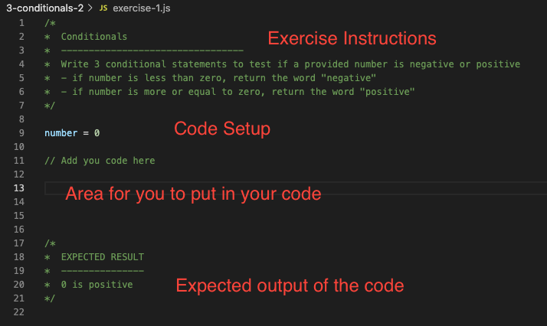

If you don’t know how to run the exercise code, please refer to the instructions in 0.1.3.

## 

## Part 3 Ternary Operator

### 3.1 Code Rewriting

Please rewrite the code block below by using Ternary Operator. Then test it with [repl.it](https://replit.com/languages/javascript).

You can paste a screenshot or type the code in the answer box.

Question 3.1.1

|  |
| --- |
| **Original Code:** |
| const studentAScore = 72;  const studentBScore = 86;  let bestStudent;  if (studentAScore >= studentBScore){  bestStudent = "A";  } else {  bestStudent = "B";  } |
| **Rewritten Code:** |
| const studentAScore = 72;  const studentBScore = 86;  let bestStudent = studentAScore >= studentBScore ? "a is larger" : "b is larger";  console.log(bestStudent); // b is larger |

Question 3.1.2

|  |
| --- |
| **Original Code:** |
| const studentAScore = 72;  const studentBScore = 86;  const studentCScore = 22;  let bestStudent;  if (studentAScore >= studentBScore && studentAScore >= studentCScore){  bestStudent = "A";  } else if (studentBScore >= studentAScore && studentBScore >= studentCScore){  bestStudent = "B";  } else {  bestStudent = "C";  }  console.log(bestStudent); |
| **Rewritten Code:** |
| const studentAScore = 72;  const studentBScore = 86;  const studentCScore = 22;  let bestStudent = studentAScore >= studentBScore && studentAScore >= studentCScore ? "A" : "B";  console.log(bestStudent); // B |

Question 3.1.3

|  |
| --- |
| **Original Code:** |
| const studentAScore = 72;  const studentBScore = 86;  const studentCScore = 22;  function getGradeFromScore(score){  if (score > 85){  return "A";  } else if (score > 70){  return "B";  } else {  return "C"  }  }  console.log(getGradeFromScore(studentAScore));  console.log(getGradeFromScore(studentBScore));  console.log(getGradeFromScore(studentCScore)); |
| **Rewritten Code:** |
| const studentAScore = 72;  const studentBScore = 86;  const studentCScore = 22;  function getGradeFromScore(score){  return (score > 85 ? "A"  : score > 70 ? "B"  : "C");  }    console.log(getGradeFromScore(studentAScore));  console.log(getGradeFromScore(studentBScore));  console.log(getGradeFromScore(studentCScore));  // B  // A  // C |

## Part 4 Submission

### Zip the whole file and upload the file to TalentLabs Learning Management System.